INFO6055 – Non Functional Testing

In Class Exercise 9

This exercise has you perform a load/stress test on a small application.

**Assignment Objectives:**

* How to do load testing using recording of applications.
* How to randomize your testing to cover dynamic behavior in your non-functional test cases.

**Requirements:**

1. You must work individually to complete this exercise.
2. You must answer perform the listed activities and answer the questions.

**Practical instructions – 25 marks**

**Pre-requisites**

The following steps are a pre-requisite for completing your assignment, and it is expected that all the following components are already installed in your laptop:

1. Download JMeter from this location (select zip file under Binaries)
   1. <https://jmeter.apache.org/>
2. You will need to use the same application attic2 that you used in the previous assignments.
3. If you don’t have Mozilla Web Browser installed in your machine, download a recent version from the following site since we will be using Mozilla web browser for our exercise.

<https://www.mozilla.org/en-CA/firefox/new/>

**Next steps**

1. In your previous assignments, you developed test plans for various applications. Unlike previous steps, for recording with JMeter test recording controller, you will need to set a proxy in your Mozilla Firefox browser. Keep in mind when you are using the proxy. Server from step 6. You can go through the following tutorial for understanding how to create a test plan using the recording option:

<https://jmeter.apache.org/usermanual/jmeter_proxy_step_by_step.html>

* 1. Create a thread group under your test plan
     1. Set the number of threads - 1
     2. Set the ramp-up period – 1 seconds
     3. Set the loop count to 1
     4. You will change these values after you get the test working.
  2. Create an Http Request Defaults
  3. Create a Http Test Script Recorder
     1. Right clicking on Test plan -> Add -> Non-test elements
     2. When you press run on this page the Recording Controller will populate with Http Requests
  4. Create an HTTP Recording Controller
  5. Add a Graph Results
  6. Add a View Results Tree

Your test plan should end up looking like this one.

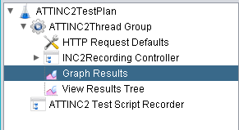

Click on start button found in the http test script recording element. Once you hit on start, you will get an error regarding certificate is not installed.

In order to install the certificate in Mozilla firefox browser, you need to go back to the options tab in Mozilla firefox, and type certificate in the search option.

Import the certificate manually which you should be able to find from jmeter\bin directory.

Now you should start doing your actions, and the test script should be automatically recorded.

After the script is recorded, save your work.

Click on run for executing test, observe the result.

Your View Results tree should show all green

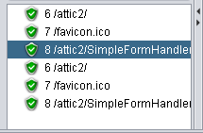

1. Execute your test.
2. Modify your thread group
   1. Set the number of threads - 100
   2. Set the ramp-up period – 10 seconds
   3. Set the loop count to 10
3. Although you normally would not use the graphical interface to run a load test we will.
4. Run your load test once.
5. Use a **screen capture** to record the results of the “Graphics Results”. Paste results below.
6. Use a **screen capture** to record the results in the “Views Results Tree”. Paste results below.
7. Run your test again.
8. Use a screen capture to record the results of the “Graphics Results”. Paste results below.
9. Use a screen capture to record the results in the “Views Results Tree”. Paste results below.

**Questions – 5 marks (Put your answers immediately under questions below in this document)**

1. In which situation, recording your tests would be helpful?

**Ans : In situation when we require our application to be operate automatically, We require Recording. It is very useful to record and analyse the data for later use.**

**The recorded information is used for various purposes like removing errors.**

1. Observe your result from different listeners. What are the different listeners presenting to you regarding your result?

**Ans :2.)Different listeners provide output on various metrics.**

**For instance, View Result Tree is used to filter data in form of HTML, Text or expressions according to request and response headers, body etc.**

**Whereas ,**

**View Results in Tree is used to show threads information based on start time, label, status, bytes , latency , connect time.**

1. What other features could improve your test plan?

**Ans :3.)Many features can be there if all the advanced feature can be used in HTTP test script recorder. All the features improve its functionality.**

Set proxy in Mozilla firefox driver for JMeter test recording

From options, search proxy, and set the manual proxy settings as the following.

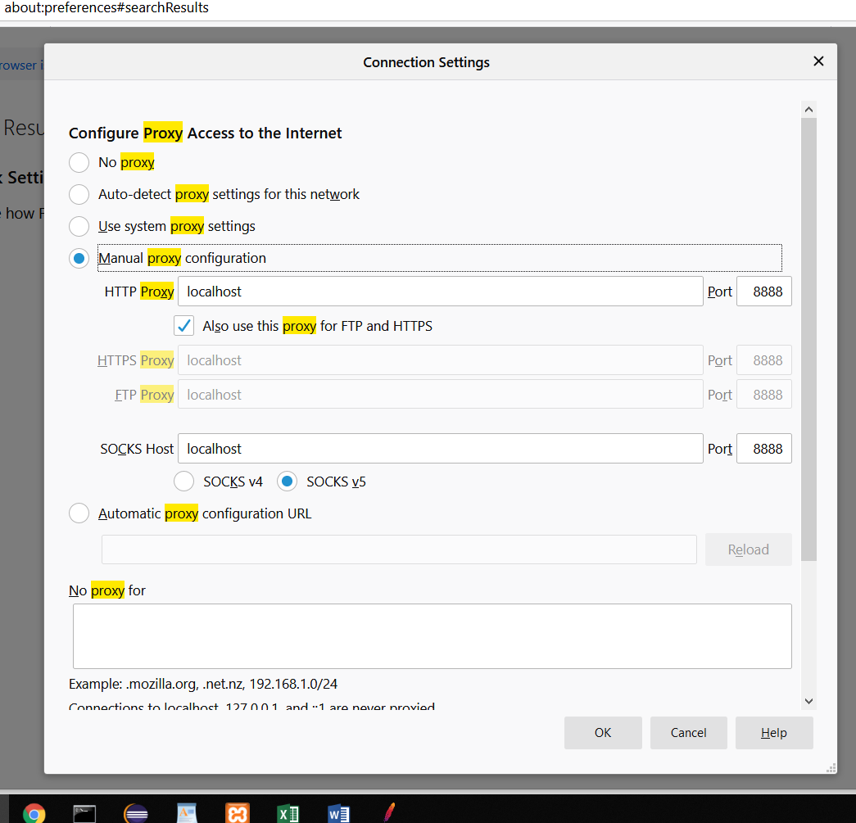

Click ok.

Now your browser will redirect through JMeter before it hits Tomcat.

This will allow JMeter to record you using the application.

**What to hand in.**

Your JMeter file (jmx) file.

A word document with a title page containing your name, student id and assignment 2 and the screen captures that you were asked for and the answers to the questions.

RESULTS

